Lab4 Tasks Muhammad Umar Roll no #25k-3077
Task 1:
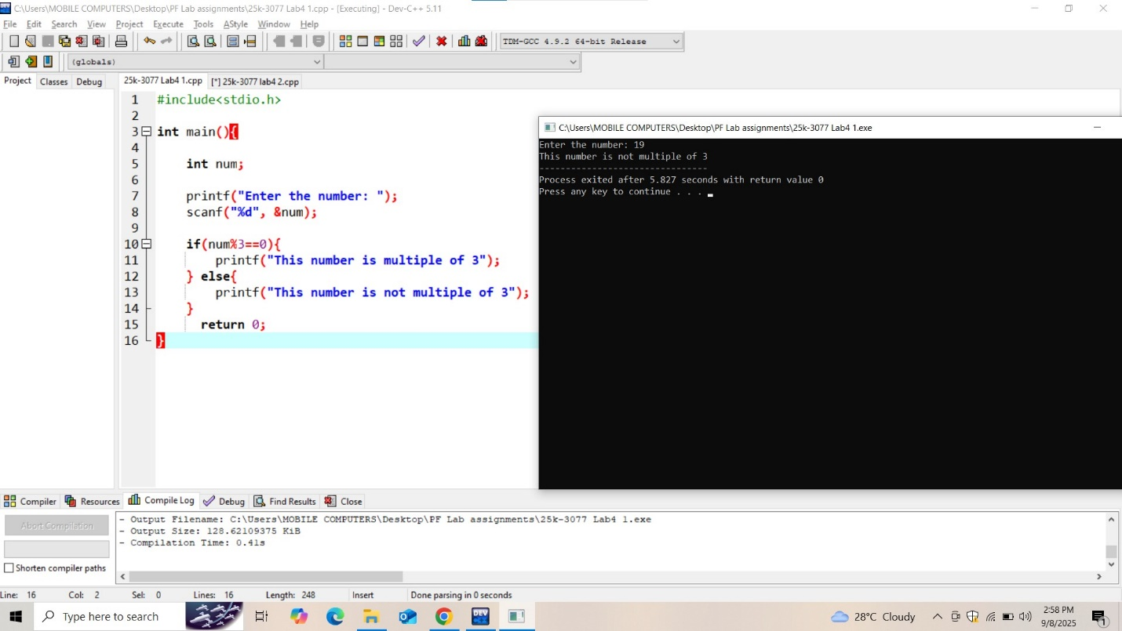

Task 2:
